10-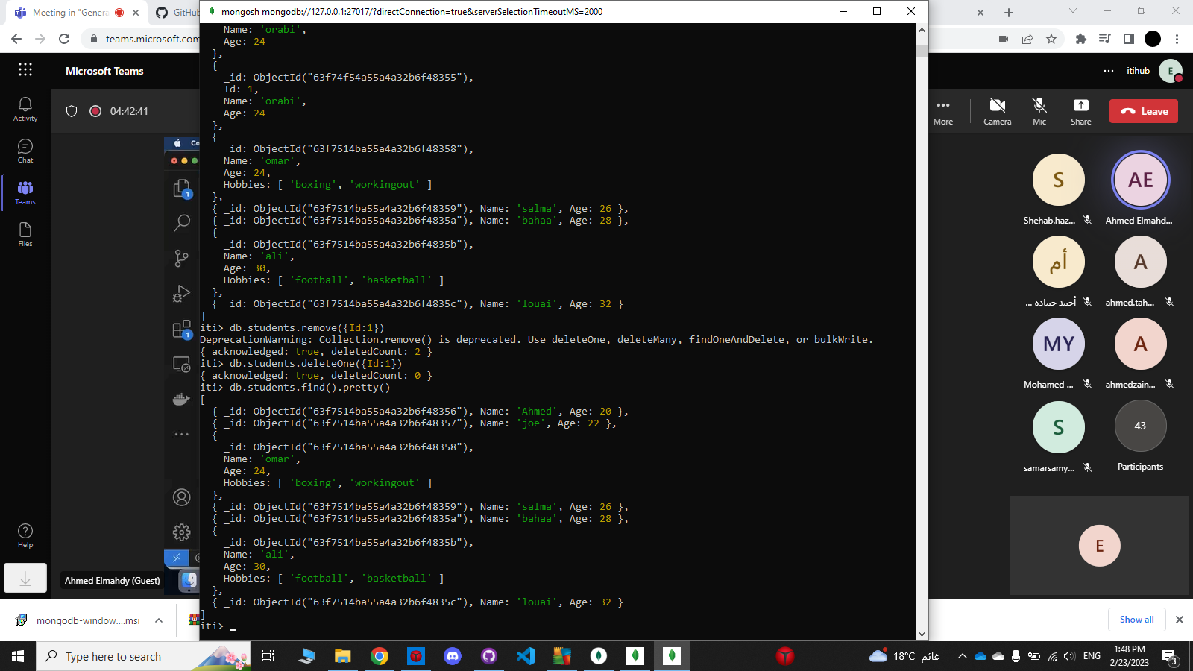

Part2:

2-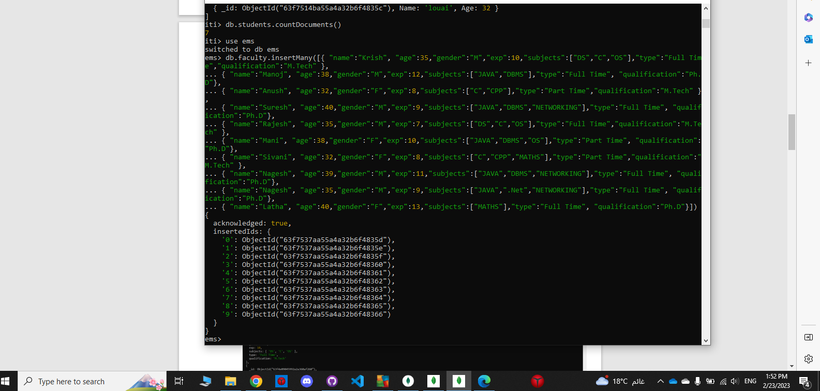

4-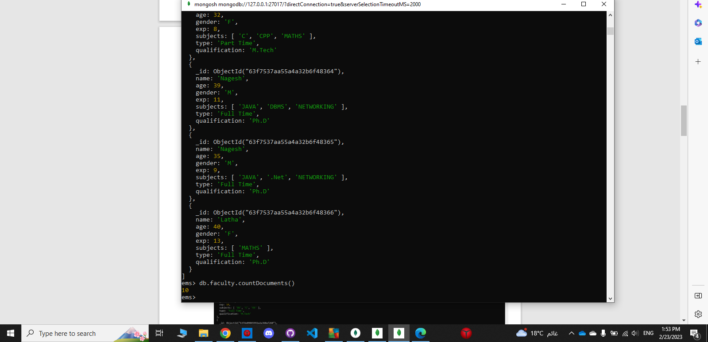

7-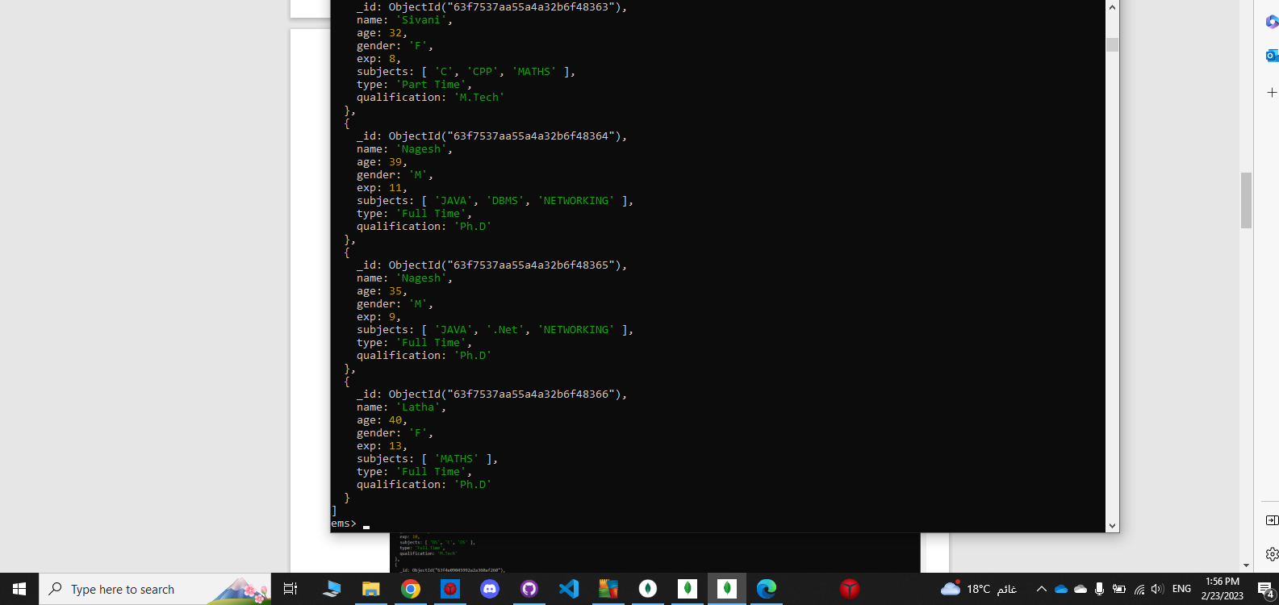

14-

